Print off this chart to help count your syns for Christmas week. Cross off a snowman for each syn you use! Some will choose to use flexible syns or a measured amount each day. The most important thing is to stick to the amount in the chart :)

 | 1 | 2 | 3 | 4 | 5 | 6 | 7 | 8 | 9 | 10 | 11 | 12 | 13 | 14 | 15
22ND | 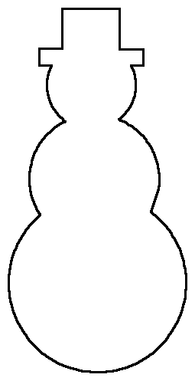
23RD
24TH
25TH
26TH
27TH
28TH
29TH

